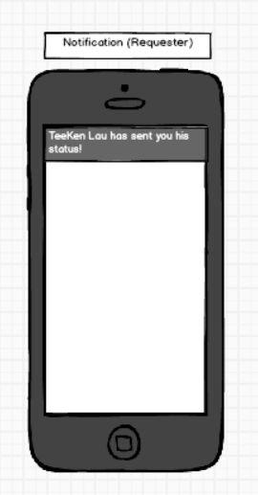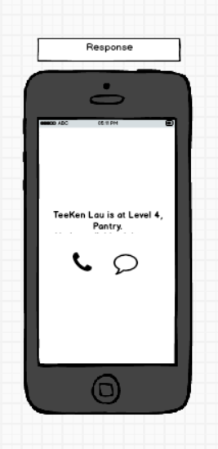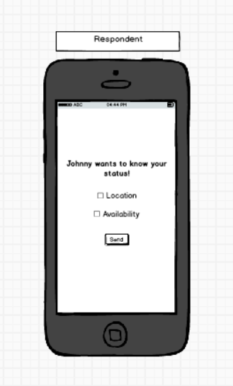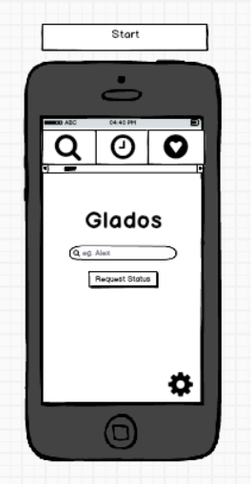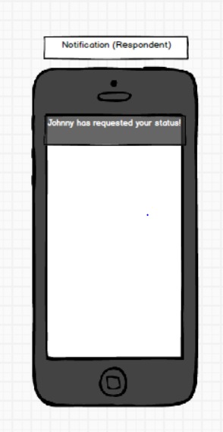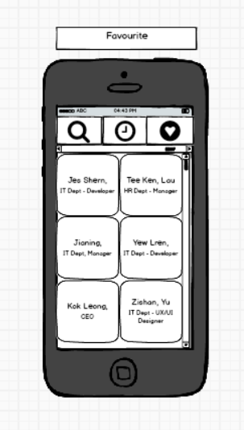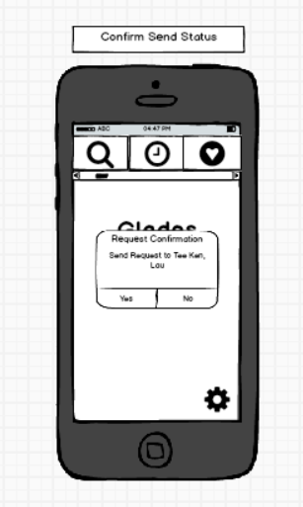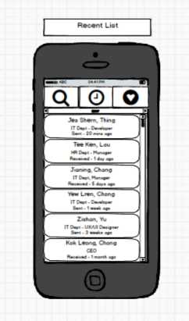

Information is displayed based on the respondent’s selection of location and availability.

if unavailable, only the message link is displayed to avoid disturbance.

Notification from respondent along with name (Clickable)

Tick on checkbox for type of information to be sent. Press send to confirm.

Notification from requester along with the name (Clickable)

Tap on a recent contact to request status. Contact details include name (first & last), department, type and time of request.

Choose Yes to confirm request, No to cancel

Tap on a contact box to request status. Contact details include first name, last name and department.

Search by name (Suggestions below search) and request location of certain person